Cancer Center Hub Client (CCHC) 1.1

caXchange – ScenPro, Inc.

End User Guide

DOCUMENT CHANGE HISTORY
Version Number | Date | Contributor | Description
1.0 | 2/11/2008 | Anupama Sharma | Initial Draft
1.1 | 2/14/2008 | David Dorman | Reviewed and edited
1.2 | 7/14/2008 | Bill McCurry | Updated for Release 1.1


Updated July 14, 2008

Contact Information
Contacts and Support
NCICB Application Support | http://ncicb.nci.nih.gov/NCICB/support  Telephone: 301-451-4384  Toll free: 888-478-4423

LISTSERV Facilities Pertinent to software teams
LISTSERV | URL | Name

TABLE OF CONTENTS
1. Summary 1
2. Introduction 2
2.1 Overview 2
2.2 Dependencies 2
2.3 Security 2
3. Installation Steps 3
3.1 Zip file 3
4. Application Operation Steps 3
4.1 MAIN Window 3
4.1.1 Main page 3
4.1.2 .CSV to HL7V3 Settings. 4
4.1.3 HL7V2 to HL7V3 Settings 5
4.1.4 Common Settings 6
4.1.5 User Credentials Settings 7
4.1.6 Help Action 8
4.1.7 Accept Action 9
4.1.8 Clear Action 10
4.1.9 Close Action 11
4.2 STATUS WINDOW 12
4.2.1 View Status Logs. 12

Summary
The Cancer Center Hub Client (CCHC) is a stand-alone desktop application. It is used to transform lab data in the form of .CSV files and HL7V2 messages to HL7V3 message format. These HL7V3 messages are saved in the CTODS database using the Grid Services.

CCHC transformation functions include:
- User sets their transformation preferences.
- CCHC performs the transformation service using these user preferences and by invoking caAdapter APIs.
- CCHC invokes the Grid Service to perform study lookup on a participant to pre-populate study information in the HL7V3 message.
- CCHC saves the generated HL7V3 message into the CTODS database.
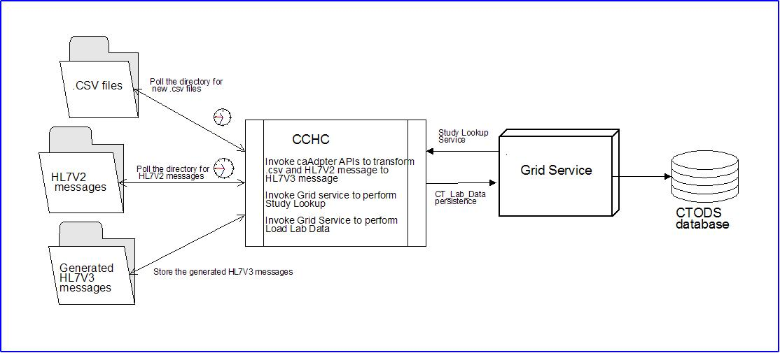
Figure 1 Cancer Center Hub Client (CCHC) Message Transformation Process

Introduction

Overview
This user guide identifies and describes the general features and functionality as provided and displayed by CCHC version 1.0. This document has been published to specifically support the use of CCHC.
This document describes the CCHC user interface capabilities and components with screen shots that have been augmented with graphic elements (i.e. boxes, lines, text, etc.). CCHC documentation can be accessed at:
https://gforge.nci.nih.gov/plugins/scmcvs/cvsweb.php/caxchange/?cvsroot=caxchange

Dependencies
The assumptions and dependencies to support the use of CCHC by a user include:
- The CCHC is available for use on an authorized system.
- Current system security protocols are in place and operational.
- The user has access and authorization to use CCHC.

Security
CCHC accesses, displays, and brokers sensitive individually identifiable patient health information. It is the user’s responsibility to ensure that CCHC is used appropriately, to include:
- Exclusively limit the viewing of patient information to authorized personnel only.
- Patient information shall not be released in any form to anyone not directly authorized to view and use the information.
- Patient information will only be searched and displayed for purposes directly related to NCI officially sanctioned tasks and purposes.
- The user shall log out and close the browser at the conclusion of the session.
- The user shall not provide another with their unique user ID and password that is used to access CCHC.

Installation Steps

JAR file
1. Download the CCHC-installer.jar file from the caXchange wiki page to any folder on your system.
2. Open the folder and find the CCHC-installer.jar file; then double click on the file to start the CCHC installation routine.
3. The CCHC Installation Welcome Screen will display.
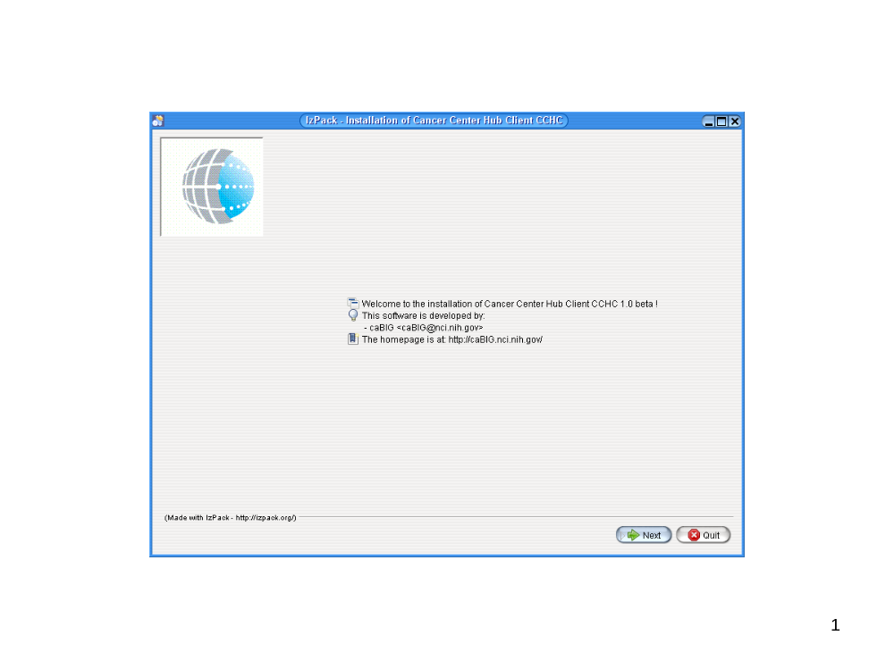
Figure 2 CCHC Installation Welcome Screen

Main installation procedure

Welcome Page
- In order to continue the installation procedure, click on Next.
- In order to exit the installation procedure without installing CCHC, click on Quit.
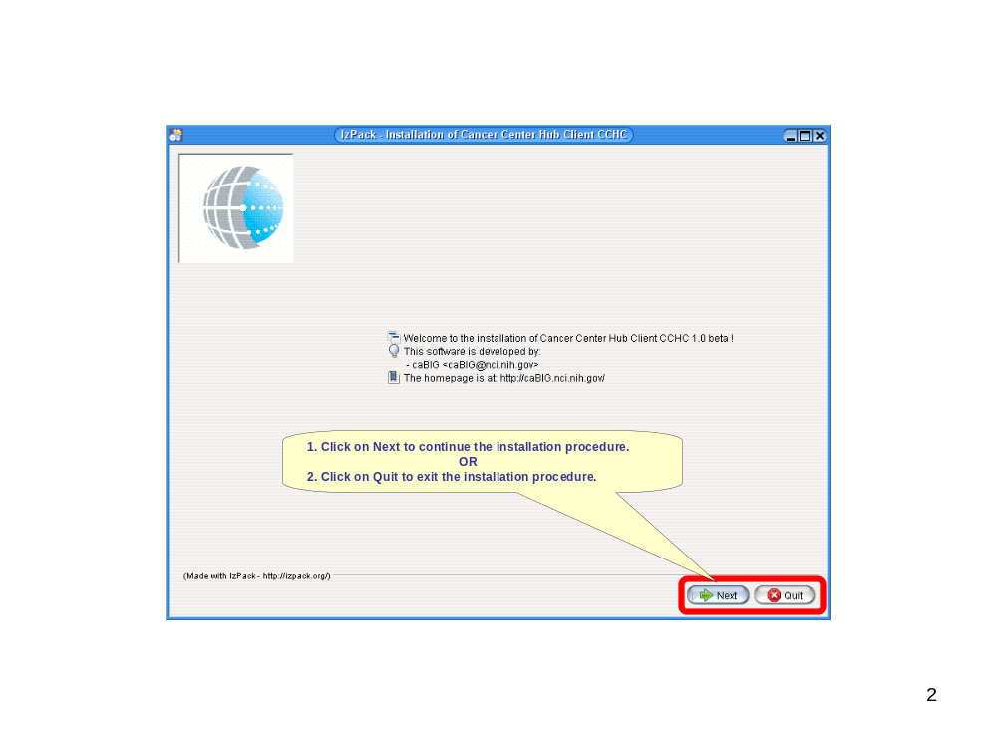
Figure 3 Continuing the Installation or Quitting the Installation

License Agreement Page
- In order to accept the terms of the license agreement, click on the radio button next to the statement accepting the terms of the license agreement.
- If you do not wish to accept the terms of the license agreement, click on the radio button next to the statement indicating that you do not accept the terms of the license agreement. Note that if you do not accept the terms of the license agreement you will not be allowed to continue with CCHC installation.
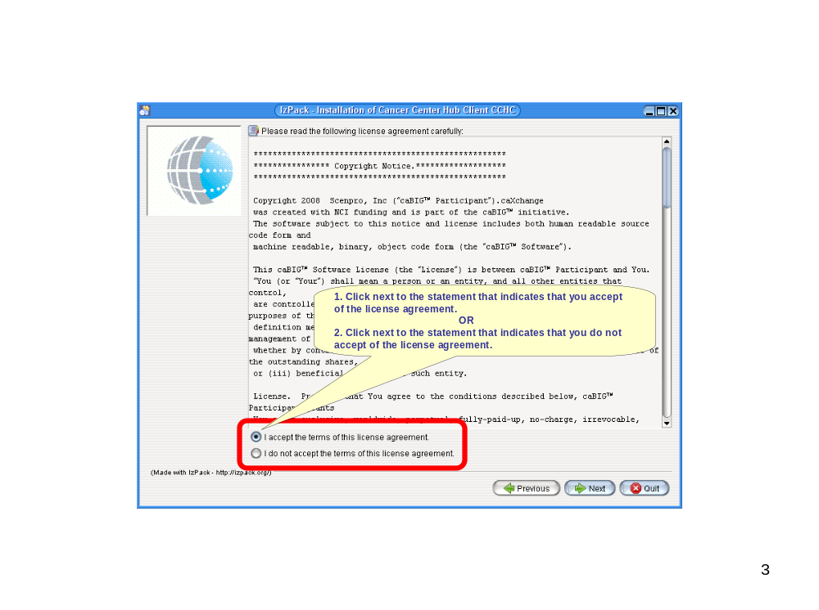
Figure 4 Accepting the License Agreement
- If you have accepted the terms of the license agreement the Next button will be enabled. Click Next to continue with the installation procedure.
- If you want to return to the CCHC Installation Welcome Page click Previous.
- If you want to exit the installation procedure click Quit. Note that if you do not accept the terms of the license agreement you must either return to the Welcome Page or Quit.
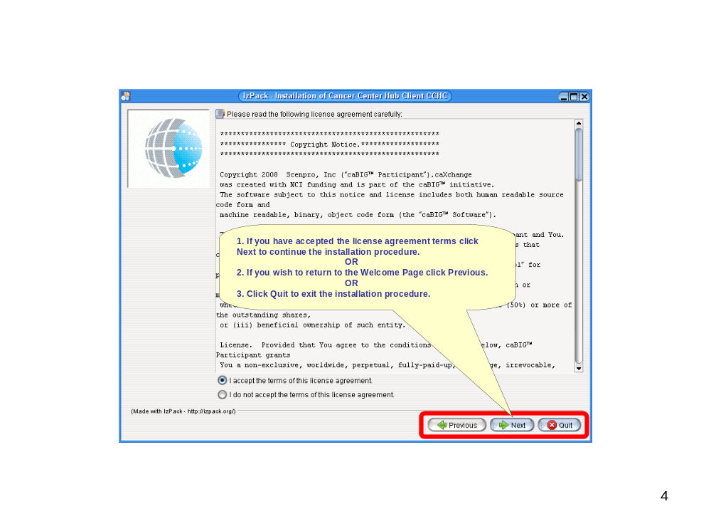
Figure 5 Continuing or Quitting the Installation After License Agreement

Select Installation Folder Page
- Click Browse to browse to the folder in which you would like to install the Cancer Center Hub Client.
- If the folder in which you would like to install the Cancer Center Hub Client does not yet exist, type in the location (path) and name of the folder you would like to create and install the application into.
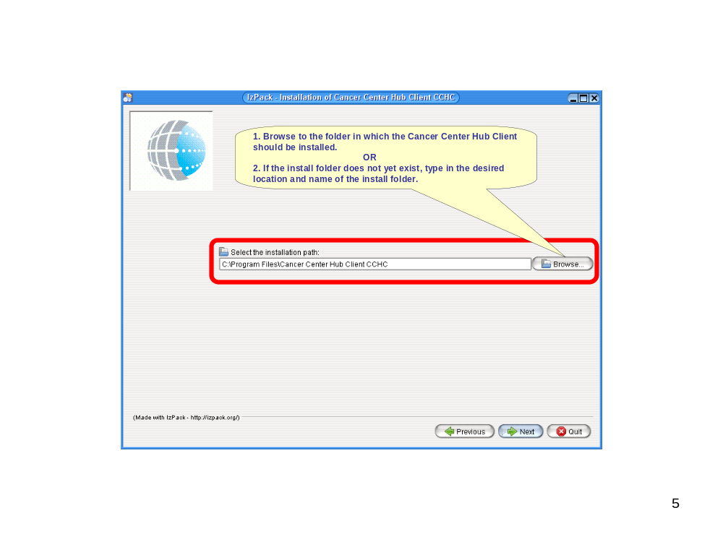
Figure 6 Selecting the Installation Path and Folder
- Once the installation path and folder are selected, click Next to continue the installation procedure.
- If you wish to return to the License Agreement page, click Previous. Note that in this case the installation procedure will not retain the installation path and folder you may have selected.
- If you wish to exit the installation procedure, click Quit.
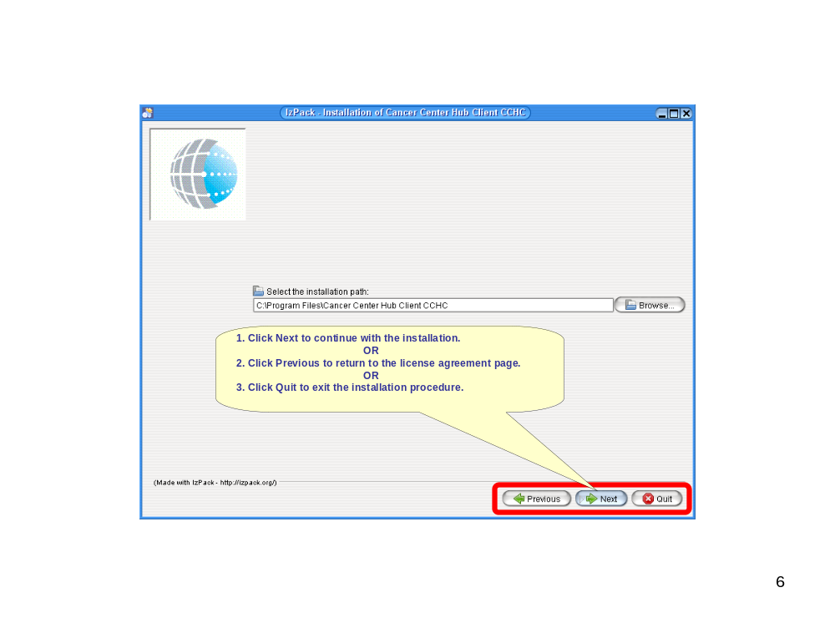
Figure 7 Continuing With the Installation After Selecting the Installation Path
- If the installation folder you designated does not already exist, the installation procedure will ask you to confirm that you want to create the installation folder. Click OK to confirm, and the installation procedure will create the installation folder.
- If you do not wish to create the installation folder, click Cancel and the installation procedure will return you to the Select Installation Folder page where you may select or enter a different installation folder.
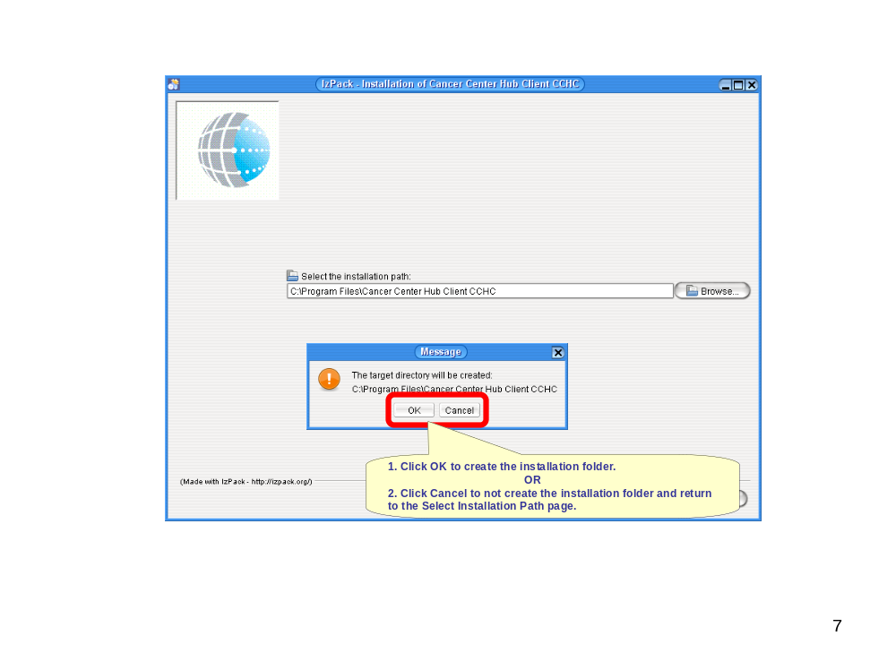
Figure 8 Confirm Creation of Installation Folder

Select Packs to Install Page
- The Select Packs to Install Page will display a list of the CCHC Installation Packs you may install. Select the packs you wish to install by clicking on the boxes to the left of the names of the packs so that an X appears in each box. Note that packs that are grayed out are required.
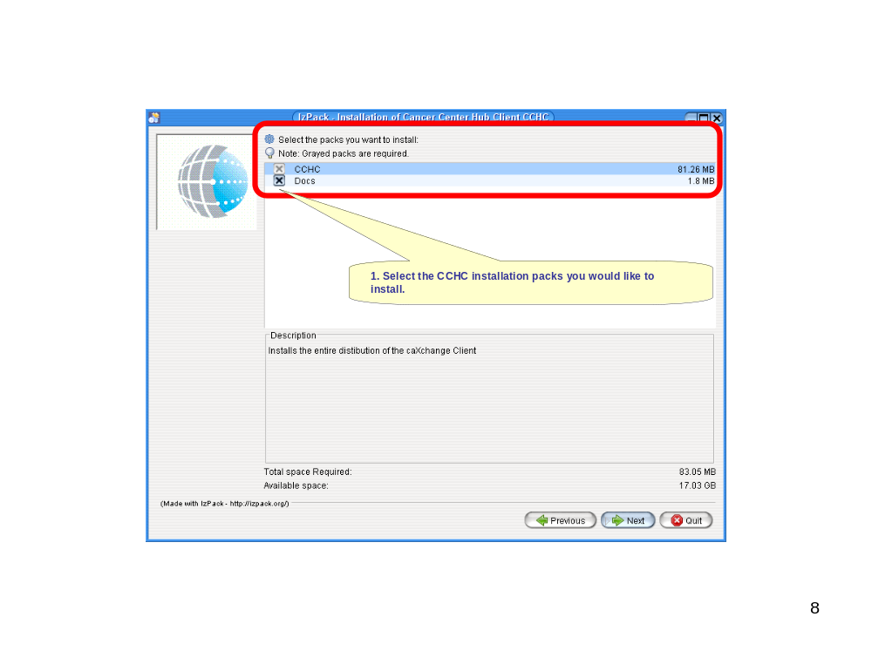
Figure 9 Select Packs to Install
- The page displays the space required to install the selected packs and the space available on the selected drive. If the drive does not have sufficient space for the installation, click Previous to return to the Select Installation Folder page and select a different drive.
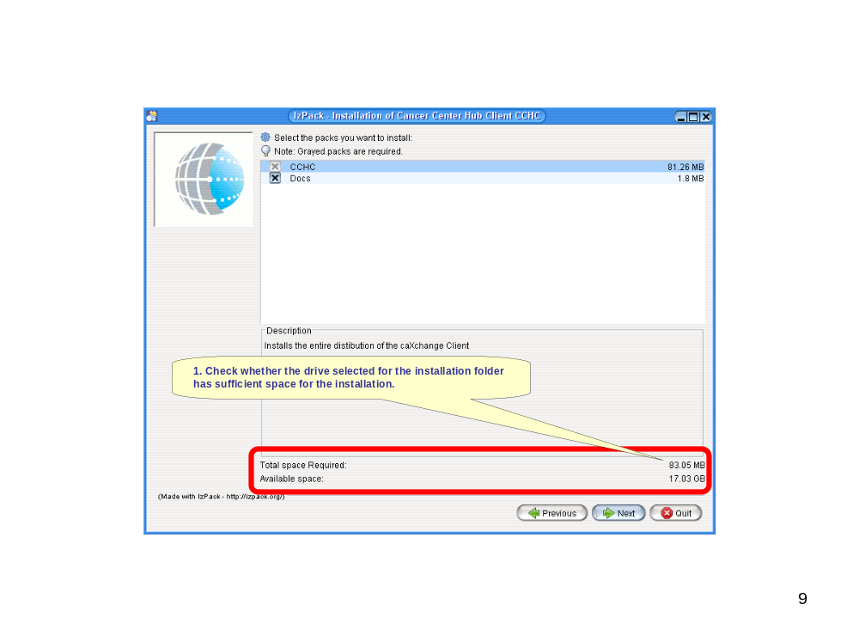
Figure 10 Check Whether There is Sufficient Space Available For Installation
- Click Next to continue the installation procedure and install the selected packs.
- If you wish to return to the Select Installation Folder page, click Previous.
- If you wish to exit the installation procedure, click Quit.
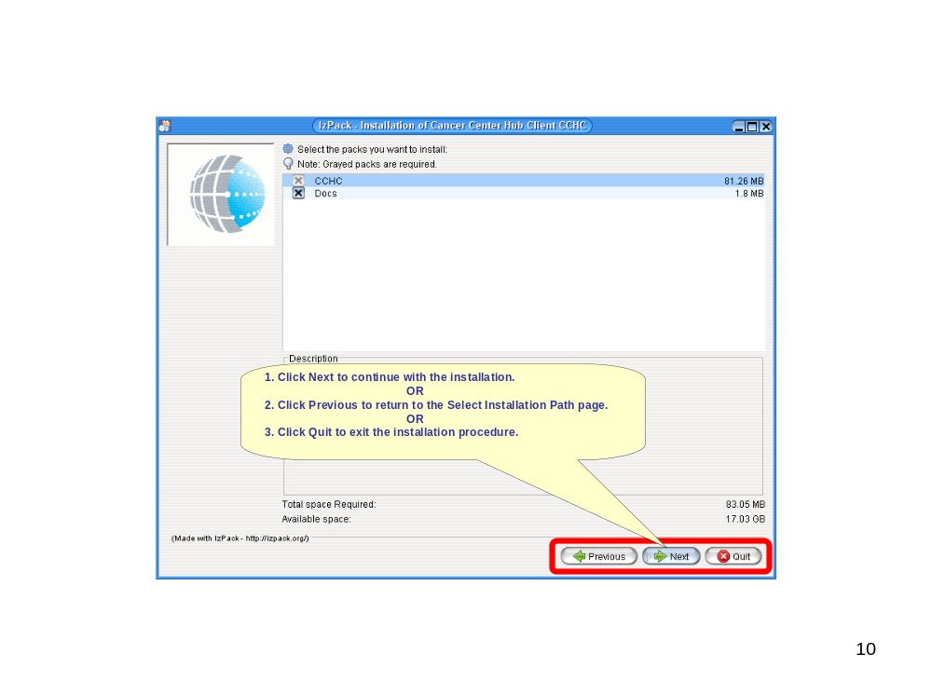
Figure 11 Continue the Installation Procedure After Selecting the Packs to Install

Installation Progress Page
- The Installation Progress Page will display two progress bars. The top bar shows the progress of installation of the currently displayed pack. The bottom bar shows the progress of installation of all the selected packs.
- When all selected packs have been successfully installed, the Next button will become enabled.
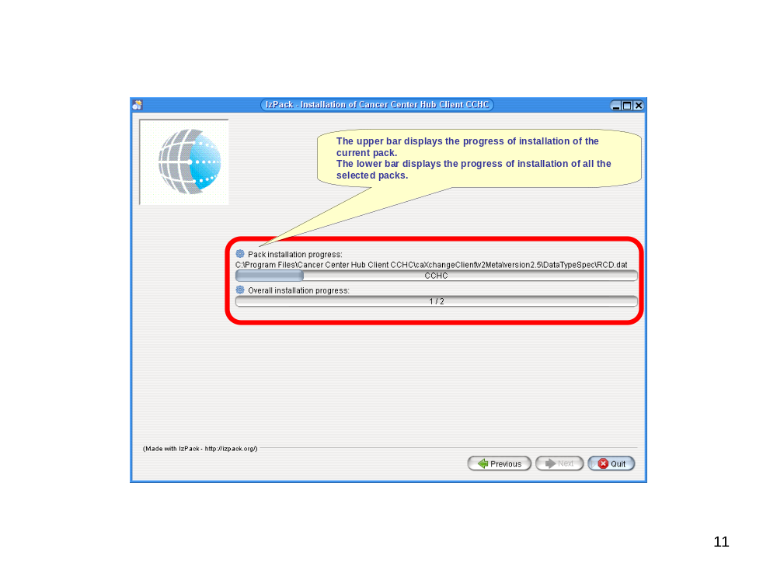
Figure 12 Installation Progress
- Once the packs have been installed and the Next button becomes enabled, click Next to continue the installation procedure.
- If you wish to return to the Select Packs to Install page, click Previous.
- If you wish to exit the installation procedure, click Quit. In this case CCHC will be installed but there will be no shortcuts in the Start Menu or on the desktop to launch CCHC. If CCHC is installed without shortcuts, you may open the folder in which CCHC was installed and double click on the run.bat file to launch CCHC.
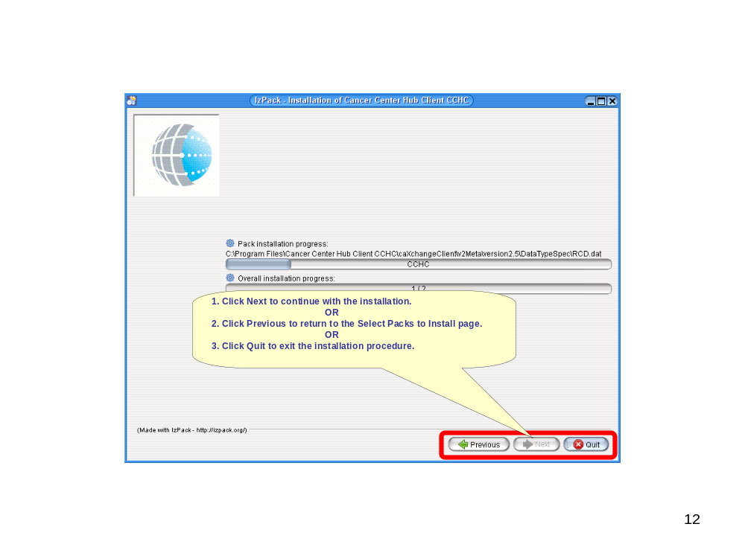
Figure 13 Continue with Installation Procedure After Installation Progress

Setup Shortcuts Page
- If you want to create a shortcut for the CCHC application in the Start Menu, ensure that the check box next to that item is checked.
- If you want to create a shortcut for the CCHC application on the Desktop, ensure that the check box next to that item is checked.
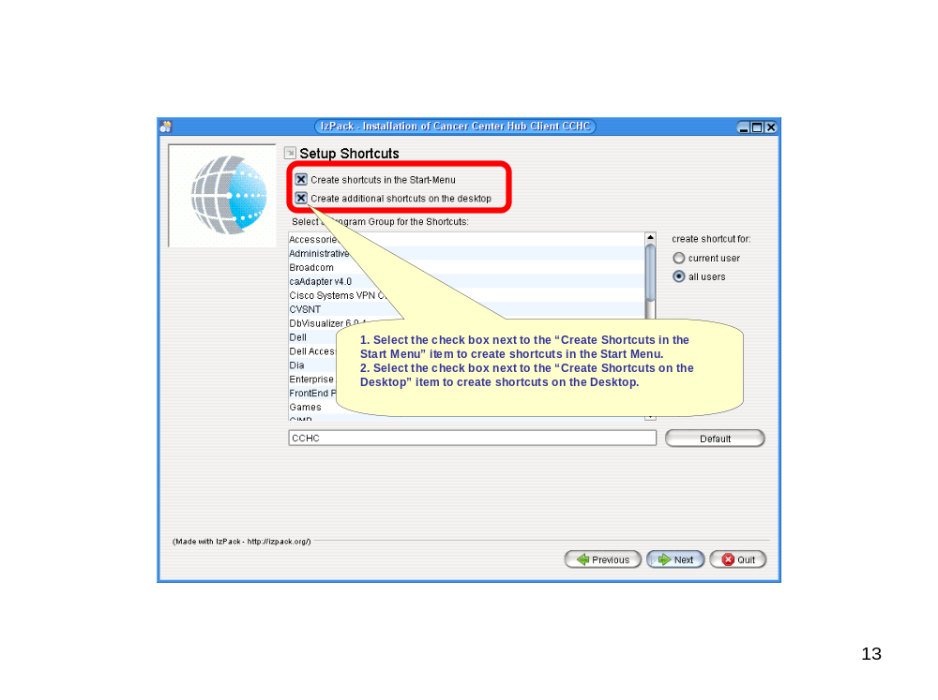
Figure 14 Select the Desired Shortcuts
- If you want the CCHC Start Menu shortcut to appear in an existing program group, select that program group from the list.
- If you want to create a new program group for the CCHC shortcut, type the name of that program group in the text box.
- If you want to use the default program group, click the Default button.
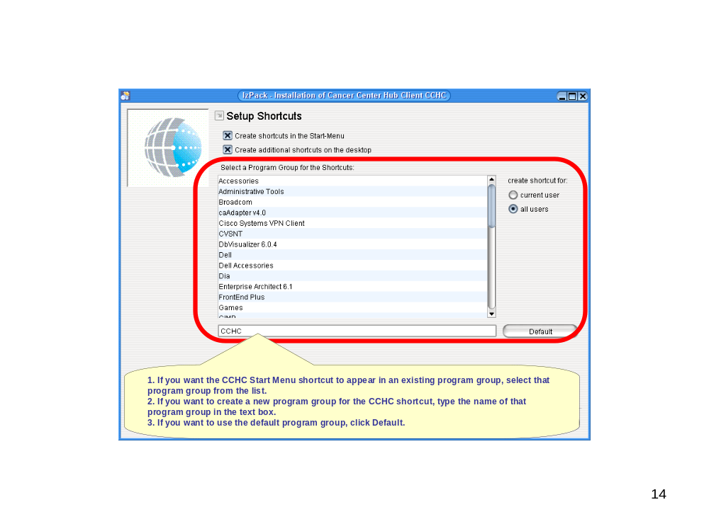
Figure 15 Select Program Group for Shortcuts
- Select whether the shortcuts should be created for all users or only for the current user.
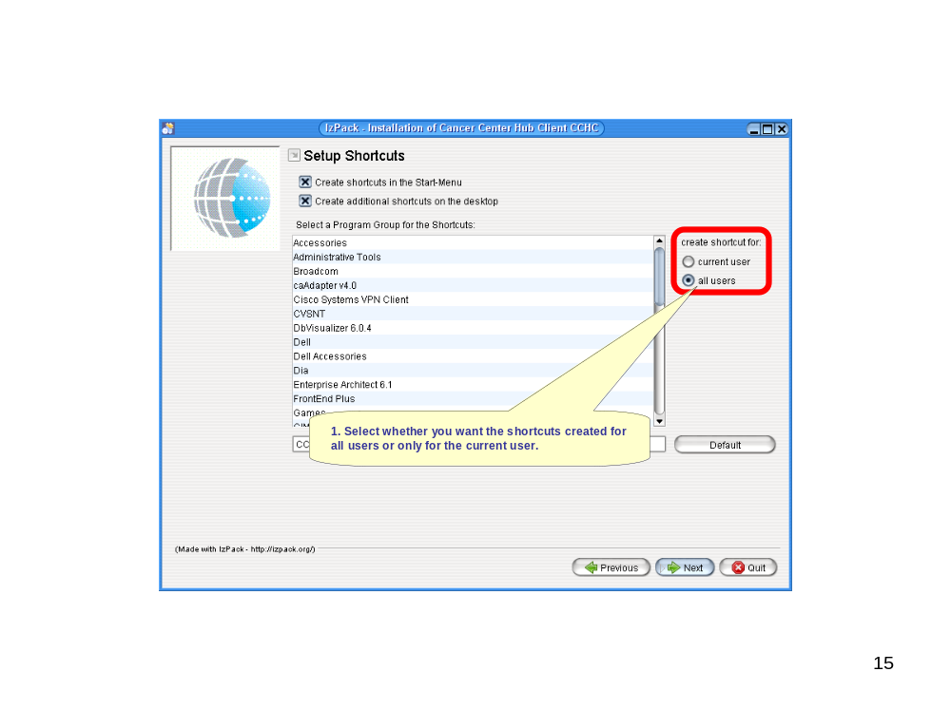
Figure 16 Select Users for Shortcuts
- Click Next to continue the installation procedure and create the desired shortcuts.
- If you wish to return to the Installation Progress page, click Previous.
- If you wish to exit the installation procedure, click Quit.
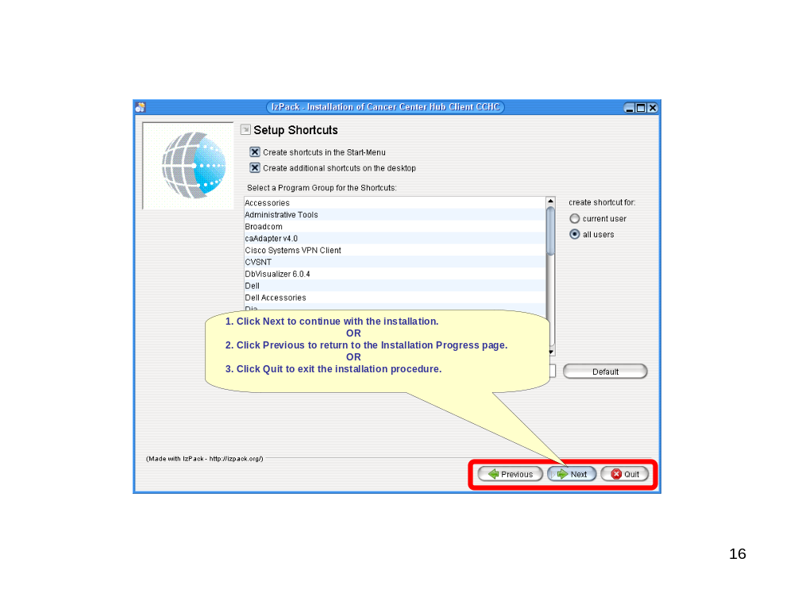
Figure 17 Continue With Installation After Shortcut Setup
- The Installation Confirmation Page will display. Note that the user need not generate an automatic installation script.
- Click Done on the Installation Confirmation Page to complete the installation procedure.
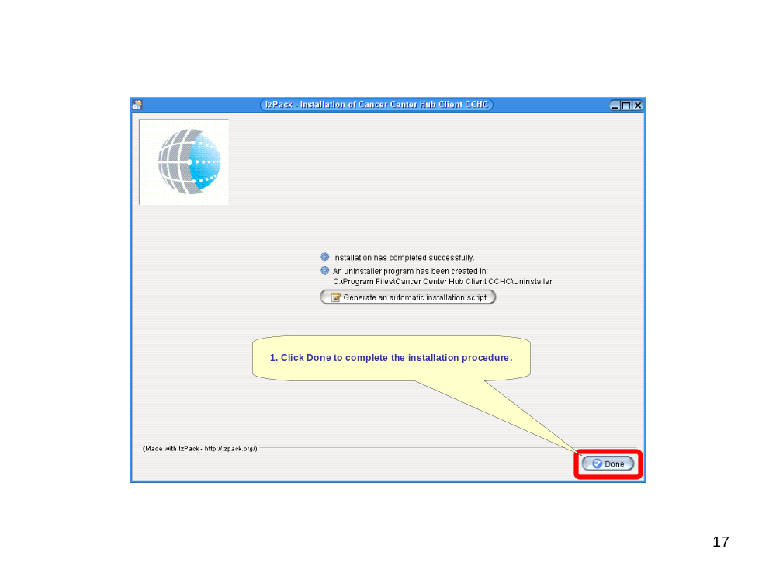
Figure 18 Complete the Installation Procedure
- The shortcuts that were selected during the installation procedure will be available in the Start Menu and/or on the desktop.
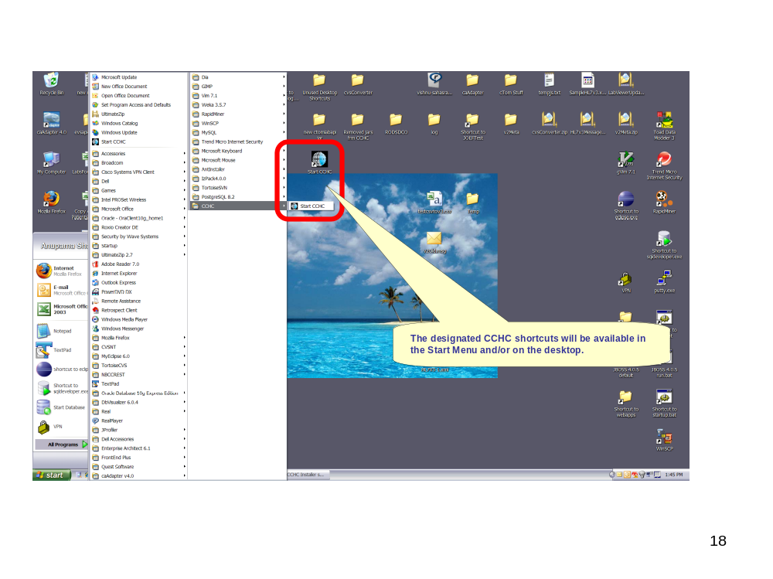
Figure 19 CCHC Shortcuts

Application Operation Steps

MAIN Window

Main page
1. Activate the CCHC shortcut that was installed in either the Start Menu or on the desktop.
2. CCHC main page will display.
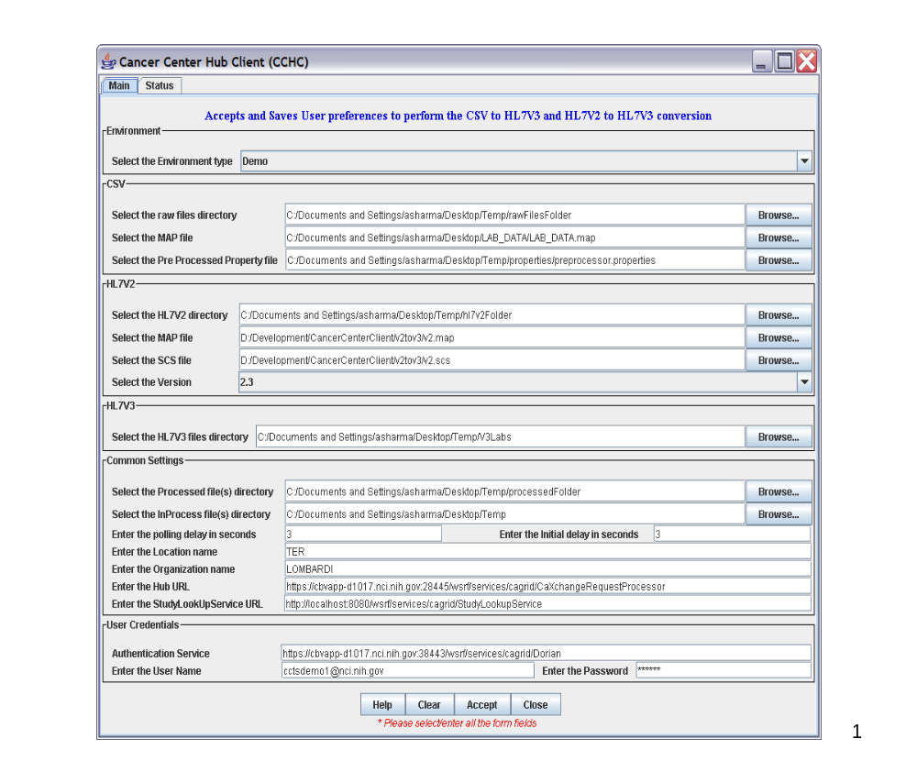
Figure 20 Cancer Center Hub Client (CCHC) Main Page

Environment Settings.
- Click on the drop down box in the Environment settings area to display the available environments.
- Select the desired environment from the drop down list.
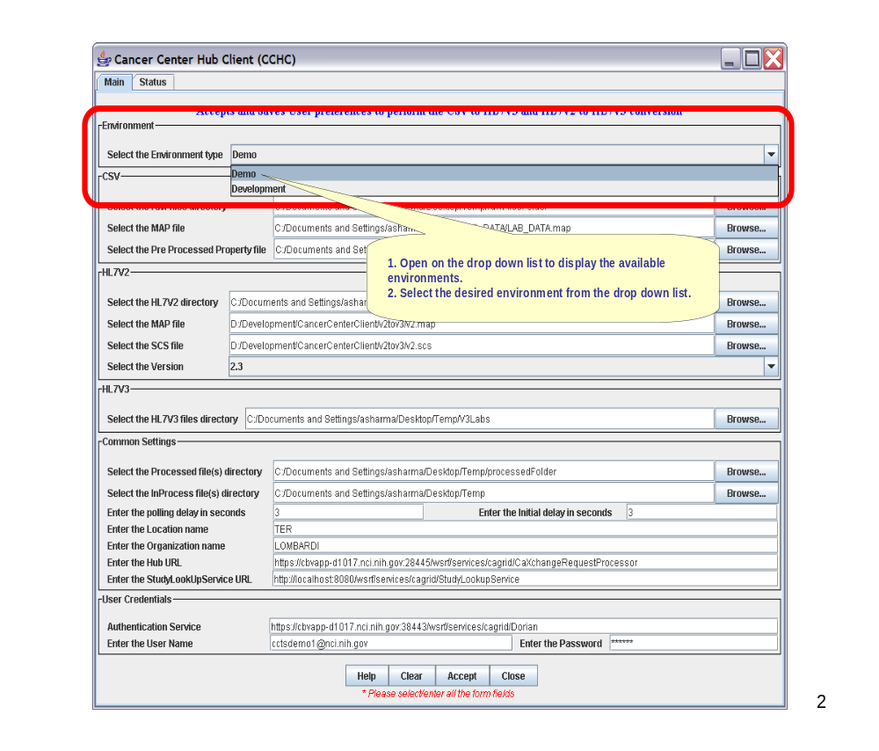
Figure 21 Selecting the Environment

.CSV to HL7V3 Settings.
- Browse and select the directory in which the .CSV files desired for the transformation will be stored.
- Browse and select the MAP file that will be used to transform the .CSV file to an HL7V3 message.
- Place all the .CSV files to be converted to HL7V3 message under the directory set in “Select the raw files directory”.
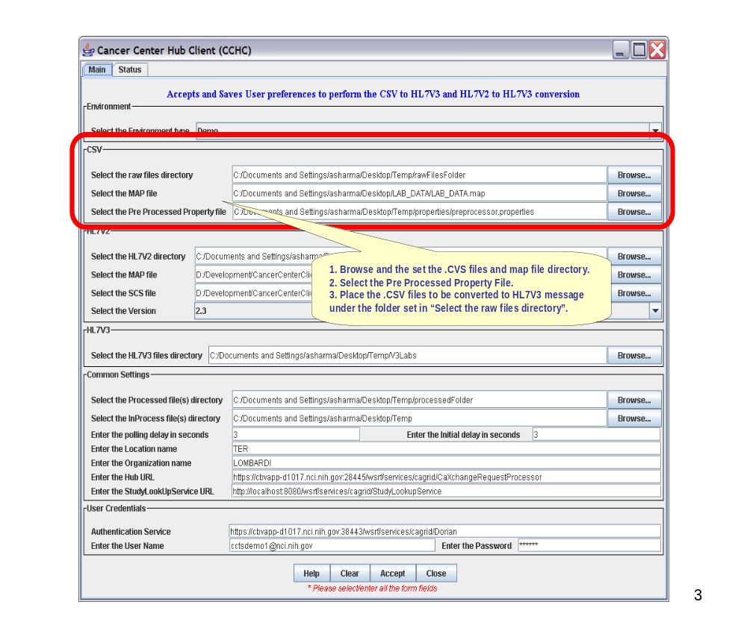
Figure 22 .CSV to HL7V3 Transformation Properties

HL7V2 to HL7V3 Settings
- Browse and select the HL7V2 files directory.
- Browse and select the MAP file to be used to transform the HL7V2 file to HL7V3 message.
- Select the SCS file required for the transformation.
- Set the version of the V2Meta to be used for the transformation.
- Place the HL7V2 files to be converted to HL7V3 message under the folder set in “Select the HL7V2 directory”.
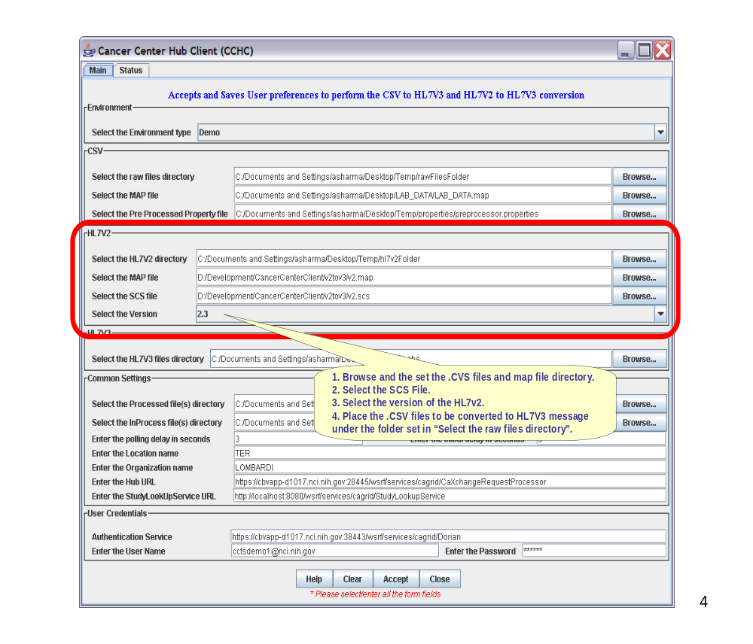
Figure 23 HL7V2 to HL7V3 Transformation Properties

HL7V3 Files Directory Settings
- Browse and select the HL7V3 files directory.
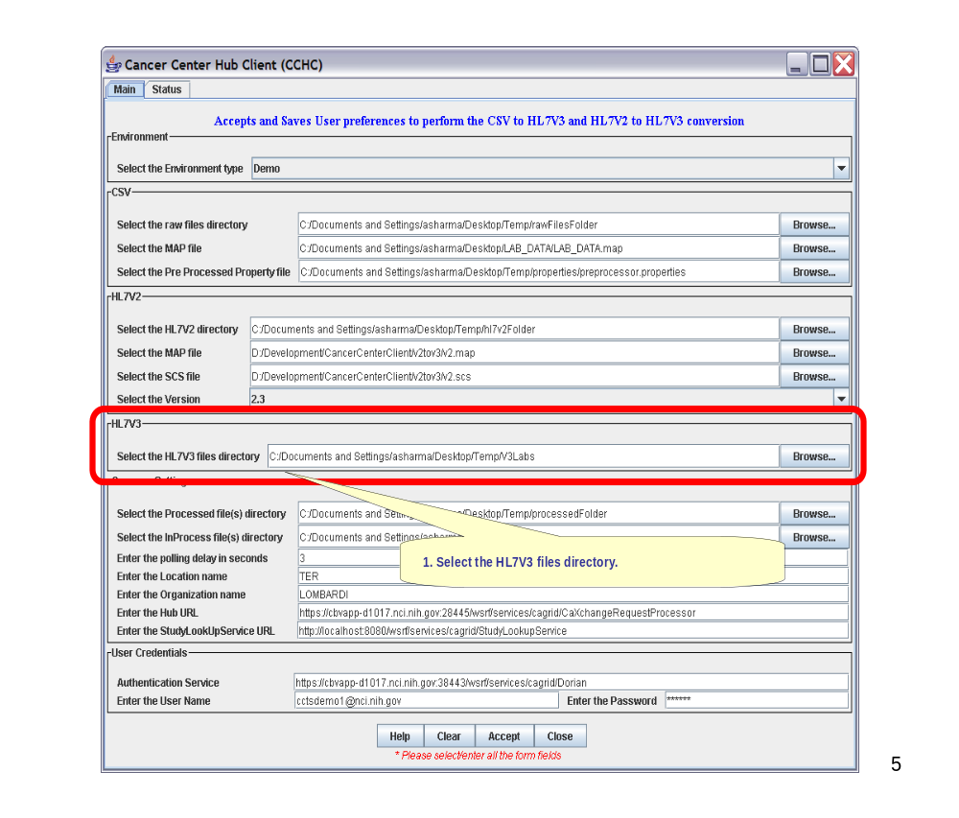
Figure 24 HL7V3 Files Directory Settings

Common Settings
Follow the steps as described below to set the common settings:
- Select the folder in which to put the processed files.
- Select the InProcess directory.
Note: This directory is used to create the InProcess folders like the rawFilesBackup folder and errorFolder. All the files that are processed through the application are stored in the rawFilesBackup folder for future reference. Files that ‘error out’ during the transformation process are moved to the errorFolder.
- Enter the polling interval and the initial polling delay interval.
Note: The unit of interval time is in seconds.
- Enter the Location name.
- Enter the Organization name.
- Enter the Hub URL to load the lab data.
- Enter the Study Lookup Service URL.
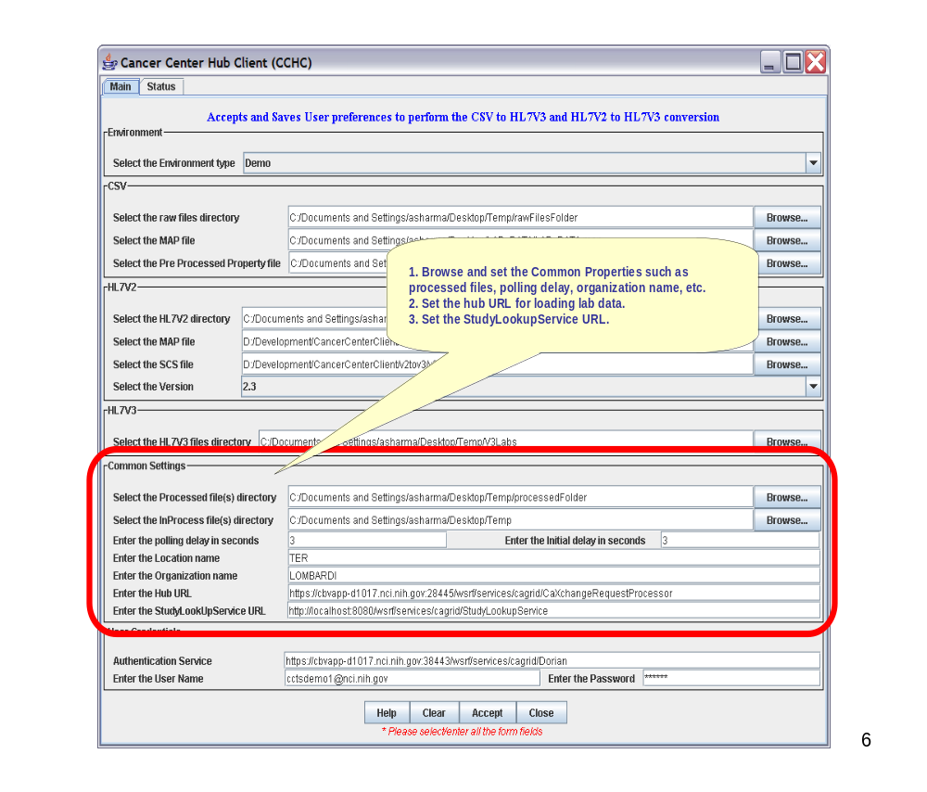
Figure 25 Common Transformation Properties

User Credentials Settings
- Enter the user credentials –username and password.
Note: This is used to check if the user is authorized to send a request to load lab data and to perform lookup service using the Grid Service.
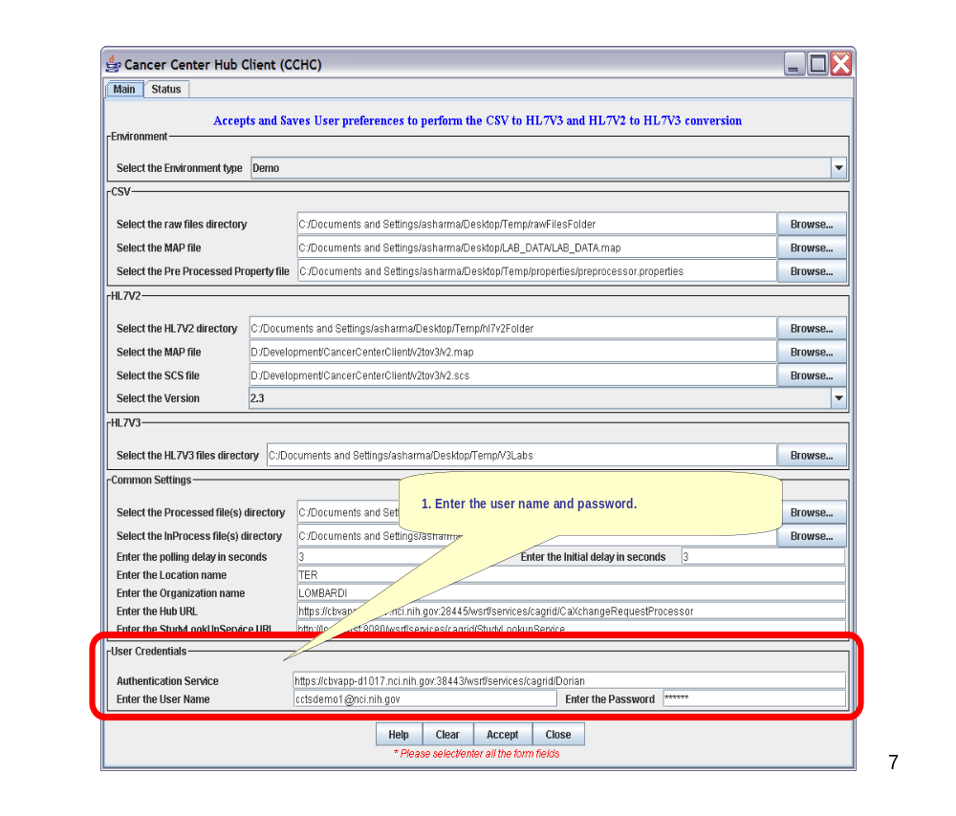
Figure 26 User Credential Settings

Help Action
- Selecting/Clicking the Help button will open the CCHC End User Manual.
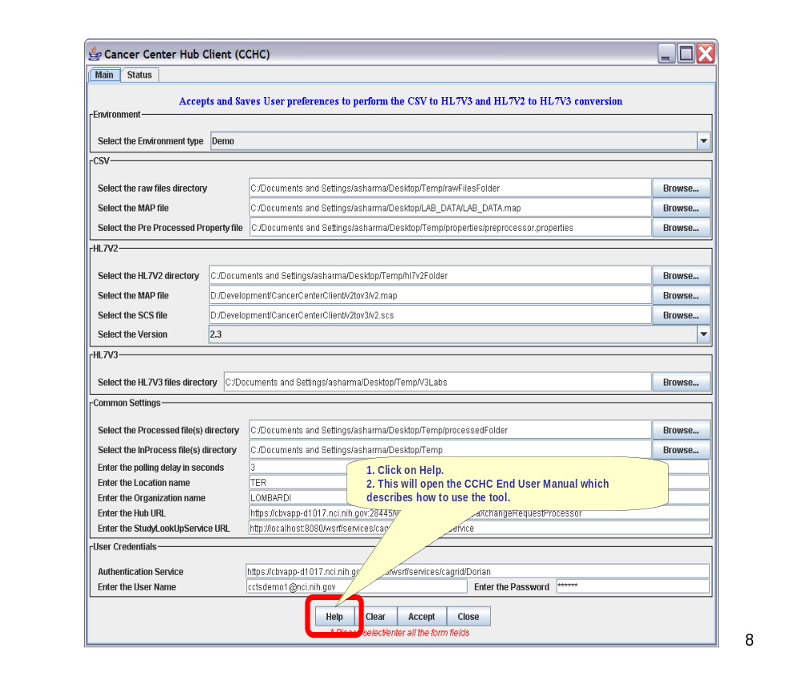
Figure 27 Access Help

Accept Action
- Selecting/Clicking the Accept Button will save the user preferences into a properties file and start the process of polling the directories for new .CSV files and HL7V2 files.
Note: The properties file can be accessed and modified in the future. The properties file gets saved in the properties directory under the zip file extracted folder.
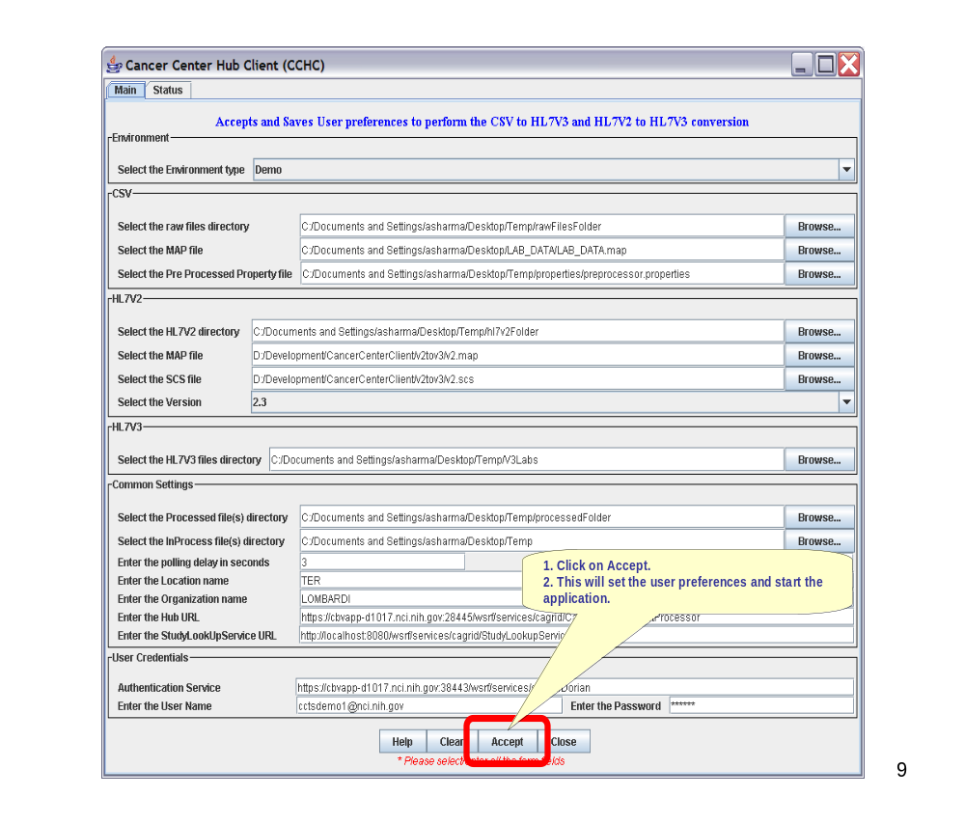
Figure 28 Accept Transformation

Clear Action
- Selecting/Clicking the Clear Button will clear all the fields and user settings.
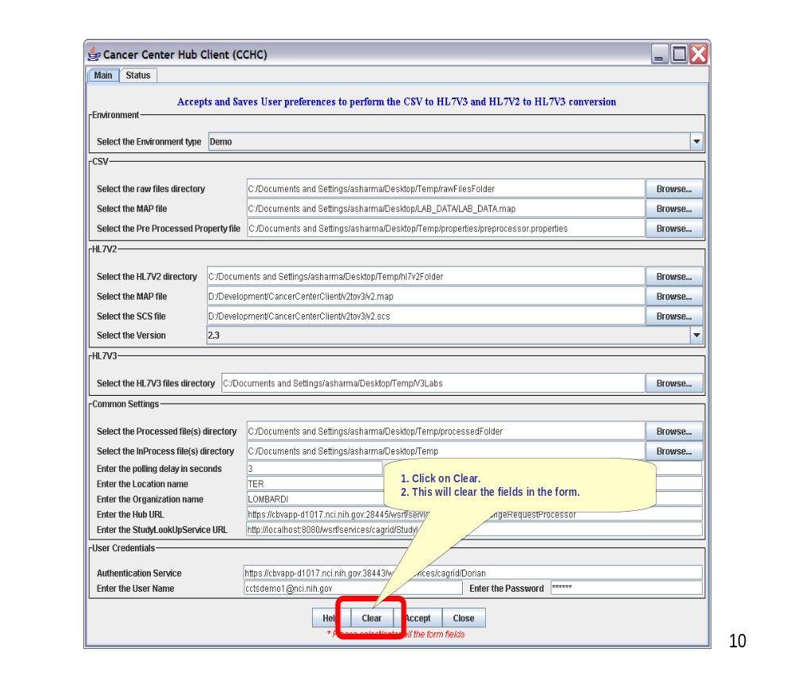
Figure 29 Clear Action Feature

Close Action
- Selecting/Clicking the Close button will close the GUI and stop the process of polling the directories for new .CSV files and HL7V2 files.
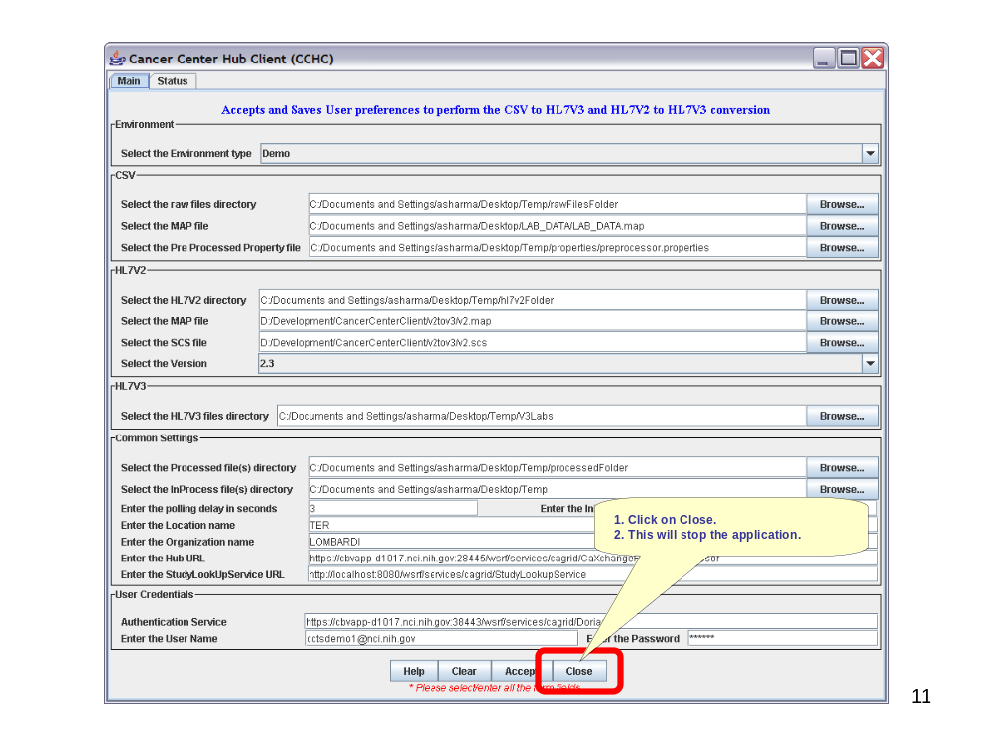
Figure 30 Close Application

STATUS WINDOW

View Status Logs.
- Select the Status tab to view status data.
Note: The status screen displays the log messages from the application. The log file is saved under the log directory in the zip file extracted folder.
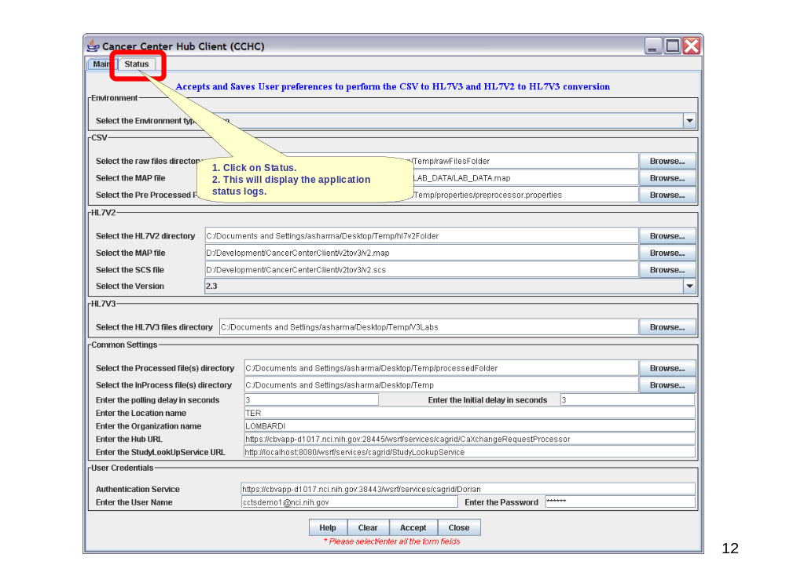
Figure 31 Status Tab
- The status window displays.
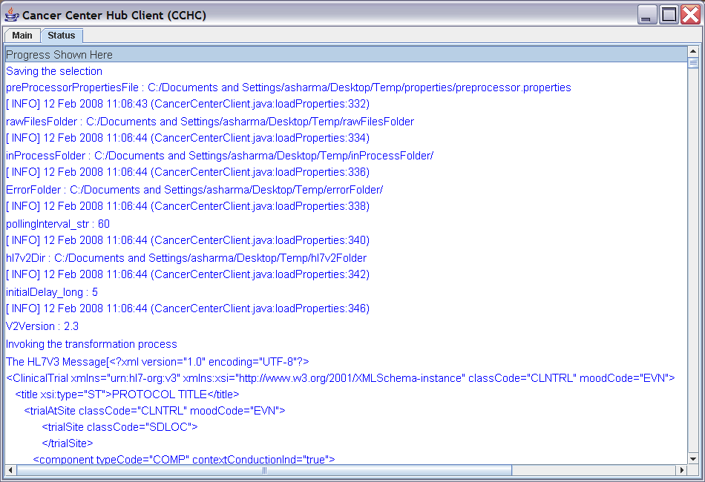
Figure 32 Status Window

